Journal Title: WHO Drug Information-Free Journal access
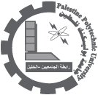
One Free Journal access
Journal Title: WHO Drug Information Description : WHO drug information provides an overview of topics of current relevance relating to drug development and regulation. Latest lists of proposed and recommended International Nonproprietary Names for Pharmaceutical Substances (INN) are also included. Complete Issues can be downloaded from the following link:
http://www.who.int/medicines/publications/druginformation/en/
01/08/2010

