اكثر من 200 كتاب و 8000 مقالة علمية الكترونية مجانية

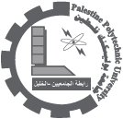

InTech - Open Access publisher in the fields of Science, Technology and Medicine

200+ books, 8,000+ articles, 20,000+ authors

Browse By Subject

http://www.intechweb.org/

18/10/2010

Biological Sciences (9)

Computer and Information Science (83)

Earth Sciences (12)

Electrical and Electronic Engineering (99)

Engineering (50)

Materials Science (4)

Medicine (11)

Technology (13)