مجلة مهمة في مجال الهندسة- مجانية

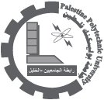

Engineering Journal www.ijest.info

International Journal of Engineering Science and Technology

This Open Access Journal will be very much useful for engineering and technology professionals due to its fast processing for publication of research articles 15/07/2010