PPU DSpace - ROMOR Workshop - On October 8, 2019

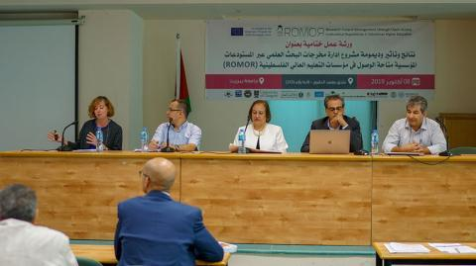

On October 8, 2019, “Birzeit University hosted the final workshop for the Research Output Management through Open Access Institutional Repositories in Palestinian Higher Education Institutions (ROMOR) project in cooperation with the Ministry of Higher Education and the Accreditation and Quality Assurance Commission, and eight Palestinian and European universities." Palestine Polytechnic University participated in this workshop, in a summary presentation about the digital repository of the university (PPU DSpace), that we spoke on several points, including: 1- PPU DSpace Project Phases… The idea was starting in December 2015, after the EIFL conducted OA workshops to raise awareness about OA and to provide an opportunity for libraries and the research community to share knowledge and information about the benefits of OA. This idea was presented to the university by the PPU library in January 2016. 2- The percentage of working (From PPU Library, Computer Center, The Deanship of Graduate Studies and Scientific Research, and PPU Researchers) in the PPU DSpace Project during these phases. 3- Who does work at PPU DSpace ??? 4- PPU DSpace Statistics (Until Now). 5- PPU DSpace Challenges and Suggestions.