Mohammad Abuhamdieh

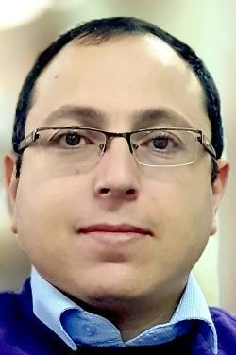

Mr. Mohammad Abuhamdieh was born in Jerusalem, Palestine, in 1982. He received his master's degree in Business Administration from Hebron University in 2015. He obtained his bachelor's degree in Information Technology from Palestine Polytechnic University (PPU) in 2006. He is one of the PPU library staff from 2007 until now. He is currently working as a Digital Library Manager. His main activities and responsibilities include administrating, updating, and managing e-services at PPU Library, such as the PPU DSpace system(E-Repository), PPU EZproxy portal, and PPU library website. He is also presenting workshops about using e-databases and free electronic resources (open access resources). He is helping the students, staff, and researchers in their researches and projects. He is also a coordinator for PPU e-databases. Currently, he is an active member of the EIFL (Electronic Information for Libraries) organization as an open access (OA) coordinator and copyright coordinator in Palestine (From 2014-Until now), he was also a project manager for EIFL - PALICO OA Project in 2015 that is funded by EIFL.

Mohammad I. A. AbuHamdieh

Abu Romman St, Hebron, WestBank, Palestine, P.O. Box "198" Tel: +970-2-2231921 Ext: 150, Fax: +970-2-2231921 Ext: 148 E-Mail: mohammadh[@]ppu.edu